Jetson Orin Nano Developer Kit Getting Started Guide
Introduction
The NVIDIA® Jetson Orin Nano™ Developer Kit empowers the development of AI-powered robots, smart drones, and intelligent cameras built on the Jetson Orin series.
With the December 2024 software update, this advanced edge computer delivers up to 70% more performance, making it an even more powerful platform for the era of generative AI.
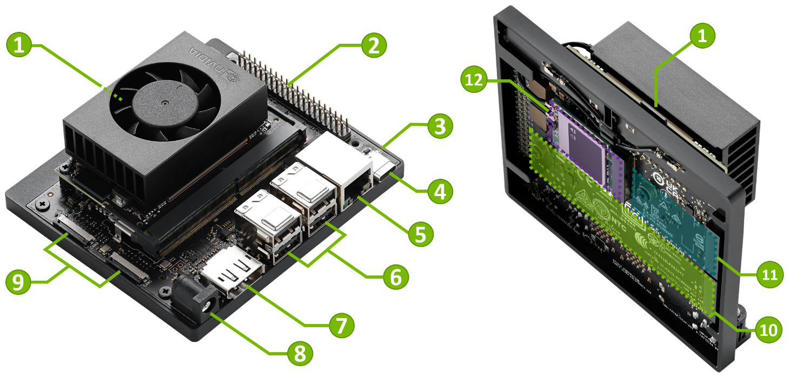

- microSD card slot for main storage
- 40-pin expansion header
- Power indicator LED
- USB-C port for data only
- Gigabit Ethernet port
- USB 3.1 Type A ports (x4)
- DisplayPort connector
- DC Barrel jack for 19V power input
- MIPI CSI camera connectors
- M.2 Slot (Key-M, Type 2280) - PCIe 3.0 x4
- M.2 Slot (Key-M, Type 2230) - PCIe 3.0 x2
- M.2 Slot (Key-E, Type 2230)

Port and Connector Details
Storage
Default storage:
- microSD card on the Jetson Orin Nano module ( 1 )
Optional storage:
- 2280-size NVMe SSD card on M.2 Slot (Key-M, Type 2280) ( 10 )
- 2230-size NVMe SSD card on M.2 Slot (Key-M, Type 2230) ( 11 )
- USB drive (on any USB port) ( 4 or 6 )
You can flash the base L4T BSP on to any of the storage medium above using SDK Manager.
For more information:
Jetson Orin Nano Developer Kit User Guide - Hardware Specs
Jetson Orin Nano Developer Kit Getting Started Guide

